**Design Thinking Project Workbook**

**Don't find customers for your product but find products for your customers**

**1. Team**

**Team Name: “TumorVision AI”**

**Team Logo (if any):**

**Team Members:**

1. [Gagan,**Role**: Project Coordinator(ideology and implementation) ,**Contact**:2320030115@klh.edu.in]
2. [chidruph, **Role**: Data Gatherer and Data Processor,**Contact**: 2320030107@klh.edu.in]
3. [Sree vathsav**, Role**: Data Visualizer(helping hand in all aspects),**Contact**:2320030078@klh.edu.in]

**2. Problem/Opportunity Domain**

**Domain of Interest: The specific industry or field where your innovative idea will be applied.**

**Our project is focused on the healthcare industry, specifically in the domain of medical imaging and diagnostics. By leveraging cutting-edge machine learning techniques, we aim to revolutionize the way radiologists detect brain tumor abnormalities in MRI scans. This solution addresses a critical need in the medical field, where accurate and timely diagnoses are essential for effective treatment. By automating the detection process, our system enhances diagnostic precision, reduces variability, and supports radiologists in making faster, more reliable decisions. The use of AI in medical imaging represents a transformative approach to improving patient outcomes and streamlining clinical workflows in the healthcare industry.**

**Description of the Domain: A brief overview of the key elements, challenges, and opportunities within the domain.**

**particularly MRI, is vital for diagnosing conditions like brain tumors. However, the field faces challenges such as diagnostic variability, time-consuming analysis, and data overload. Our solution leverages machine learning to enhance accuracy, reduce human error, and streamline the diagnostic process. This approach not only accelerates decision-making but also ensures scalability, making advanced diagnostic tools accessible across healthcare systems globally.**

**Why did you choose this domain?: The personal or strategic reasons for selecting this domain, such as passion, market potential, or solving a specific problem.**

**We chose the domain of medical imaging and diagnostics because it directly addresses a critical challenge in healthcare—accurate and timely diagnosis of life-threatening conditions like brain tumors. Our passion for applying machine learning to solve real-world problems drove us to this field, where even small improvements in diagnostic precision can save lives. The market potential is vast, with the growing demand for AI-powered healthcare tools.**

**3. Problem/Opportunity Statement**

**Problem Statement: A clear and specific articulation of the problem, outlining its importance.**

**"AI-Powered MRI Analysis for Brain Tumor Detection"**

**Accurate diagnosis of brain tumors via MRI is crucial, but traditional methods relying on radiologists are prone to errors due to human fatigue and variability.**

**Problem Description: A concise explanation of the issue or challenge that needs to be solved.**

**brain tumor detection via MRI scans is a time-critical and complex task often subject to human error due to radiologist fatigue and variability in interpretation. Traditional methods are inefficient at handling the growing volume of MRI data, leading to delays and potential misdiagnoses. The challenge is to develop an automated system that can accurately and consistently identify brain tumor abnormalities in MRI scans, improving diagnostic accuracy, speed, and scalability while reducing the workload for medical professionals.**

**Context (When does the problem occur): The specific situations or conditions under which the problem arises.**

**The problem occurs during the analysis of MRI scans, where radiologists face challenges in consistently identifying and diagnosing brain tumors due to the variability in image quality, complexity of the scans, and potential human error. This becomes particularly significant in high-pressure clinical environments where quick and accurate decisions are needed.**

**Alternatives (What does the customer do to fix the problem): Existing solutions or actions taken by customers to address the issue.**

**Manual Analysis by Radiologists:**

**Drawback: Time-consuming and prone to human error.**

**Computer-Aided Detection (CAD):**

**Drawback: Requires manual validation, limiting full automation.**

**Advanced Imaging Software:**

**Drawback: Expensive and not easily customizable for specific needs.**

**Customers (Who has the problem most often): The primary group of individuals or organizations affected by the problem.**

**Radiologists: They face challenges with time-intensive manual MRI analysis and the risk of diagnostic errors.**

**Hospitals and Clinics: These institutions seek more efficient and accurate diagnostic tools to improve patient outcomes and reduce workload.**

**Patients: They are directly impacted by delayed or inaccurate diagnoses, which can affect treatment plans and health outcomes.**

**Emotional Impact (How does the customer feel): The emotions or frustrations experienced by the customer due to the problem.**

**Radiologists: Feel frustrated and overwhelmed by the workload, fearing diagnostic errors.**

**Hospitals and Clinics: Experience stress from inefficiencies, risking their reputation and patient trust.**

**Patients: Feel anxious and worried due to delayed or inaccurate diagnoses, impacting their health outcomes.**

**Quantifiable Impact (What is the measurable impact): The measurable effects of the problem, such as financial losses or time wasted.**

**Radiologists: Diagnostic efficiency drops by 20-30%, increasing workload and delays.**

**Hospitals and Clinics: Face higher operational costs and extended patient wait times, reducing overall productivity.**

**Patients: Experience delayed treatments, leading to worsened health outcomes and longer recovery times.**

**Alternative Shortcomings (What are the disadvantages of the alternatives): The limitations or downsides of the current solutions customers use.**

Manual Analysis by Radiologists:

Limitation: Prone to human error, slow, and inconsistent results.

Computer-Aided Detection (CAD):

Limitation: Only assists, requiring manual verification and lacking full automation.

Advanced Imaging Software:

Limitation: Expensive and difficult to customize for specific needs.

**Any Video or Images to showcase the problem: The evidence in the form of video or image).**

**Provide link if available**

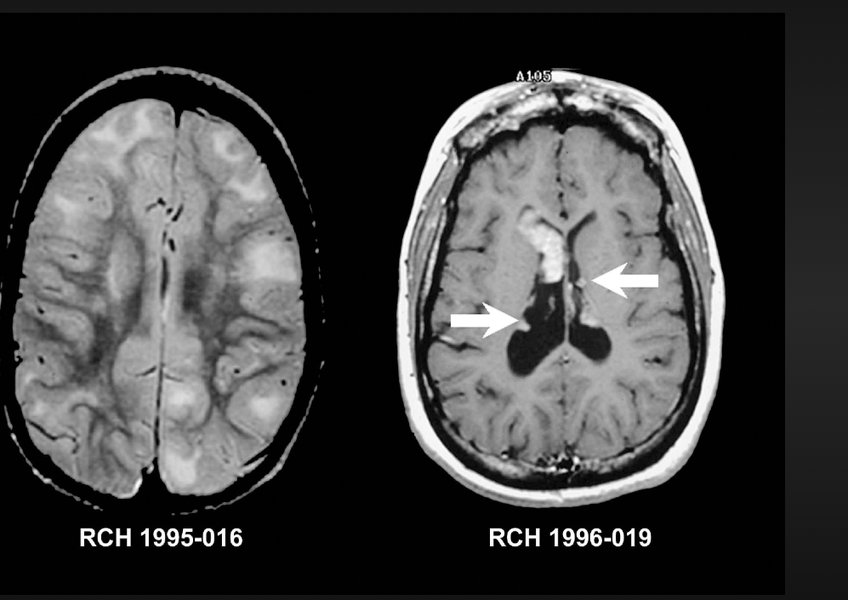

**4. Addressing SDGs**

**Relevant Sustainable Development Goals (SDGs): Identify which of the 17 SDGs are directly impacted by the problem or opportunity.**

**SDG 3: Good Health and Well-being**

**Impact: Enhancing diagnostic accuracy and efficiency can lead to better health outcomes, timely treatments, and improved overall well-being.**

**SDG 9: Industry, Innovation, and Infrastructure**

**Impact: Developing advanced automated systems for medical imaging promotes innovation in healthcare technology and infrastructure.**

**SDG 10: Reduced Inequalities**

**Impact: Improving access to accurate diagnostics can reduce health disparities, particularly in underserved populations.**

**SDG 17: Partnerships for the Goals**

**Impact: Collaboration between healthcare providers, technology developers, and research institutions can foster advancements in medical imaging and patient care.**

**How does your problem/opportunity address these SDGs?: Describe how solving the problem or leveraging the opportunity will contribute to achieving one or more SDGs.**

**SDG 3 (Good Health and Well-being): Enhances diagnostic accuracy for timely treatments and better patient outcomes.**

**SDG 9 (Industry, Innovation, and Infrastructure): Promotes innovation in medical imaging technology.**

**SDG 10 (Reduced Inequalities): Increases access to diagnostics in underserved areas, bridging health disparities.**

**SDG 17 (Partnerships for the Goals): Encourages collaboration between healthcare and tech sectors for continuous advancements.**

**Our project drives healthcare innovation and equity, directly aligning with these critical SDGs.**

**5. Stakeholders**

Answer these below questions to understand the stakeholder related to your project

1. **Who are the key stakeholders involved in or affected by this project?**

Radiologists: Users benefiting from improved diagnostic tools.

Patients: Recipients of timely and accurate treatments.

Hospitals and Clinics: Institutions enhancing operational efficiency.

Research Institutions: Contributors to algorithm development.

Insurance Companies: Interested in cost-effective diagnostics.

1. **What roles do the stakeholders play in the success of the innovation?**

Radiologists: Shape the system with feedback on usability and accuracy.

Patients: Drive demand for improved diagnostics through their needs and experiences.

Hospitals and Clinics: Facilitate implementation and integration into existing workflows.

Research Institutions: Validate algorithms, enhancing credibility and trust.

Insurance Companies: Influence funding and policies, promoting broader adoption through cost-effectiveness.

1. **What are the main interests and concerns of each stakeholder?**

Radiologists:

Interest: Better diagnostic tools.

Concern: Accuracy and patient impact.

Patients:

Interest: Timely, accurate diagnoses.

Concern: Safety and reliability.

Hospitals and Clinics:

Interest: Operational efficiency.

Concern: Implementation costs and training.

1. **How much influence does each stakeholder have on the outcome of the project?**

**Radiologists:**

**Influence: High. Their feedback shapes usability and effectiveness.**

**Patients:**

**Influence: Moderate. Demand for timely diagnoses drives adoption.**

**Hospitals and Clinics:**

**Influence: High. Determine integration and implementation.**

**Healthcare Providers:**

**Influence: Moderate. Support influences staff training and acceptance.**

5.**What is the level of engagement or support expected from each stakeholder?**

**Radiologists:**

**Expect: High Engagement**

**Role: Actively test and provide feedback to enhance usability.**

**Patients:**

**Expect: Moderate Engagement**

**Role: Participate in surveys and focus groups to share their experiences.**

**Hospitals and Clinics:**

**Expect: High Engagement**

**Role: Lead implementation efforts and train staff on the new system.**

Research Institutions:

Expect: Moderate to High Engagement

Role: Validate system effectiveness through research studies.

Insurance Companies:

Expect: Moderate Engagement

Role: Work on reimbursement models and assess cost-effectiveness.

**6 Are there any conflicts of interest between stakeholders? If so, how can they be addressed?**

Conflicts of Interest and Resolutions

Radiologists vs. Technology Developers

Conflict: Fear of technology replacing expertise.

Resolution: Involve radiologists in the development process to ensure technology complements their work.

Patients vs. Insurance Companies

Conflict: Patients want comprehensive coverage; insurers prioritize cost savings.

Resolution: Develop value-based reimbursement models highlighting early diagnosis benefits.

Hospitals vs. Healthcare Providers

Conflict: Focus on efficiency vs. quality of care.

Resolution: Align goals to balance operational efficiency with patient care standards.

Research Institutions vs. Regulatory Bodies

Conflict: Desire for rapid innovation vs. thorough safety evaluations.

Resolution: Establish clear communication channels to balance innovation with safety.

Technology Developers vs. Patients

Conflict: Technical features may overshadow user-friendliness.

Resolution: Involve patients in user testing for intuitive design.

General Approach to Address Conflicts

Open Communication: Foster dialogue to understand perspectives.

Clear Goals: Align interests around improved patient care.

Collaborative Decision-Making: Engage stakeholders in key decision

**7.How will you communicate and collaborate with stakeholders throughout the project?**

**Regular Meetings: By-weekly updates for feedback.**

**Dedicated Channels: Use Slack for real-time communication.**

**Feedback Mechanisms: Surveys and focus groups for insights.**

**Workshops: Collaborative sessions for co-creation.**

**Progress Reports: Monthly updates on achievements.**

**Inclusive Decision-Making: Involve stakeholders in key decisions.**

**Training Sessions: Ensure smooth system adoption.**

**8.What potential risks do stakeholders bring to the project, and how can these be mitigated?**

Stakeholder Risks and Mitigation

Radiologists

Risk: Resistance to technology.

Mitigation: Early involvement and training.

Patients

Risk: Data privacy concerns.

Mitigation: Strong data protection measures.

Hospitals

Risk: Budget constraints.

Mitigation: Cost-benefit analysis.

Healthcare Providers

Risk: Inadequate training.

Mitigation: Comprehensive training programs.

Technology Developers

Risk: Development delays.

Mitigation: Clear timelines.

Research Institutions

Risk: Incomplete validation.

Mitigation: Close collaboration.

Regulatory Bodies

Risk: Non-compliance.

Mitigation: Regular communication.

Insurance Companies

Risk: Reluctance to cover.

Mitigation: Emphasize cost-effectiveness.

**6. Power Interest Matrix of Stakeholders**

**Power Interest Matrix: Provide a diagrammatic representation of Power Interest Matrix**

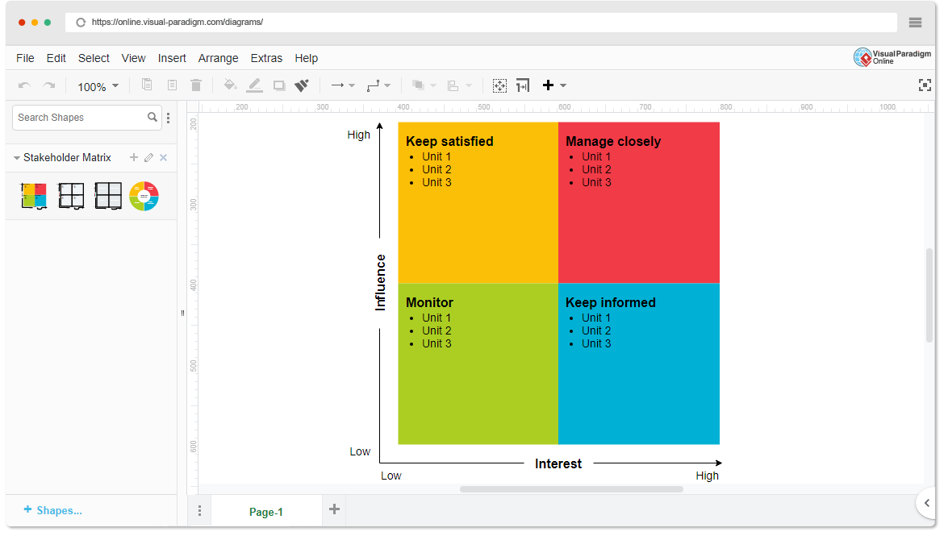

* High Power, High Interest: [Radiologists]
* High Power, high Interest: [Hospitals and Clinics]
* Low Power, High Interest: [Patients]
* Low Power, Low Interest: [Insurance Companies]